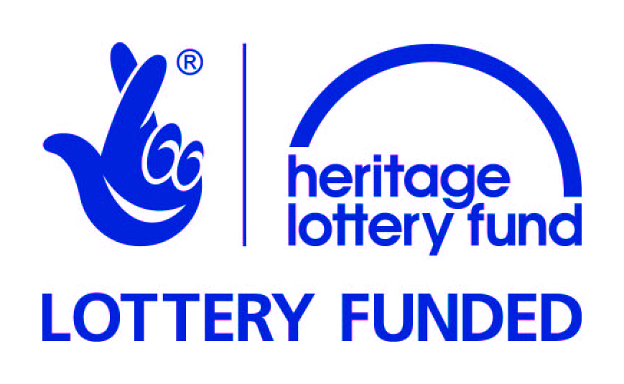

Old Toll House Restoration Project secures support from the National Lottery and Historic England

Stratford Historic Buildings Trust (SHBT) is celebrating after securing two major grants to restore and refurbish the Old Toll House on Clopton Bridge, Stratford-upon-Avon.

The Heritage Lottery Fund (HLF) has awarded a Heritage Enterprise grant of £232,400 and Historic England a building repair grant of £182,000 towards the project.

The two awards will enable SHBT to commence the physical restoration and refurbishment starting work at the end of September 2016.

This Heritage Enterprise grant builds on HLF’s significant previous investment in Stratford, and will add to the cumulative impact of HLF’s on-going commitment to Stratford’s fascinating heritage. HLF has now invested over £18million in Stratford, including £7.5million to projects exploring the life and works of William Shakespeare.

The Old Toll House, located on the medieval Clopton Bridge, was built in 1814. With its crenelated roofline and gothic windows it is a familiar local landmark and a Grade I listed building. However, over the last 30 years it has fallen into serious disrepair and has been included on Historic England’s Heritage at Risk Register.

Thanks to National Lottery players, the restoration project will preserve the historic fabric of the building and provide it with a new use as office space at ground floor and mezzanine level. In addition, the project will include a public display area in the basement and the delivery of a range of activities to explore both the history of the Toll House and also the wider industrial heritage of Stratford, much of which was originally located along the River Avon and around the canal basin.

The project has also benefited from the financial support of Stratford District Council and the Architectural Heritage Fund. The latter provided seed corn funding in the early stages and are providing a loan facility to assist with cash flow during the works.

Kevin Bond, SHBT Chairman, said: “This is brilliant news for the Old Toll House. The project has seen quite a few false dawns over the years, but securing these two grants means we can now at last start work on restoring this splendid historic building. We are extremely grateful to the Heritage Lottery Fund and Historic England as their support has been critical to making the project a reality.”

Vanessa Harbar, Head of HLF West Midlands, said: “HLF celebrates with Stratford Historic Buildings Trust as they receive their second round of Heritage Enterprise funding. Thanks to National Lottery players, this investment will continue to breathe new life into this distinctive part of Stratford’s heritage. Heritage Enterprise projects go beyond bricks and mortar; they enable historic buildings like the Old Toll House to become an important part of the economic health of communities by nurturing business and creating jobs.”

Veryan Heal, Historic England’s Planning Director in the West Midlands, said: “Historic England is very pleased to be supporting Stratford Historic Building Trust’s in conserving the Old Toll House, bringing it back into beneficial use. This beautiful, important building is one of our top ten Heritage at Risk priorities in the West Midlands and we are delighted to be part of this project.”

Notes to Editors

About Stratford Historic Buildings Trust

Stratford Historic Buildings Trust is a registered charity established in 2012.

The Trust’s purpose is to: ‘preserve for the people of Stratford upon Avon and the Historic County of Warwickshire and the Nation, the historical, architectural and constructional heritage that may exist in and around Stratford upon Avon and the Historic County of Warwickshire in buildings of particular beauty, or historical, architectural or constructional interest.’

The Old Toll House is SHBT’s first project. As well as restoring the Toll House, bringing it back into use as office space will provide the Trust with a modest income stream to act as seed corn funding to help it rescue other historic buildings at risk in the county.

About Heritage Lottery Fund

Thanks to National Lottery players, we invest money to help people across the UK explore, enjoy and protect the heritage they care about - from the archaeology under our feet to the historic parks and buildings we love, from precious memories and collections to rare wildlife. www.hlf.org.uk @heritagelottery @HLFWestMids

About Historic England

We are Historic England (formerly known as English Heritage), the public body that champions and protects England's historic places. We look after the historic environment, providing expert advice, helping people protect and care for it and helping the public to understand and enjoy it.

About The Architectural Heritage Fund (AHF)
The AHF is a registered charity, founded in 1976 by Government to promote the conservation and sustainable re-use of historic buildings for the benefit of communities across the UK, particularly in economically disadvantaged areas. It is unique in that it is able to offer support to local communities at every point in the life-cycle of their project – grants for early development work and project planning, through to loans for acquisition and as working capital for project delivery. The AHF staff also offer help and advice, giving people the skills and confidence they need to realise their ambitions.
www.ahfund.org.uk
Registered Charity No. 266780
Company limited by guarantee
Registered in England No. 1150304

Further information
For further information about Stratford Historic Buildings Trust please contact Chris Rice (Project Organiser) on 07808 887183 or rice200510@yahoo.com
For further information about the Heritage Lottery Fund please contact Felix Gott, Communications Manager, 020 7591 6138 or felixg@hlf.org.uk
For further information about Historic England please telephone our Press Office on 0207 9733 250 or by email: communications@HistoricEngland.org.uk

